WET WASTE ALLOCATIONS TO PRIVATE TRANSFER STATIONS:
Background to GOALS-BASED criteria and implementation plan

Date: April 9, 2021
Prepared By: Molly Vogt, Analytics Manager
Metro Waste Prevention and Environmental Services

Issue statement
Wet waste is a part of the solid waste system managed by Metro to serve the public good. Metro has chosen to allow a percentage of the region’s wet waste to go to private transfer stations in recognition of the value those stations provide in terms of geographic distribution of services. Staff are developing a systematic and transparent method of allocating a portion of regional wet waste tonnage to private transfer stations to support progress toward regional goals and ensure the provision of important public services.

Connection to the Regional Waste Plan
In March 2019, Metro adopted the 2030 Regional Waste Plan (RWP) which sets the policy direction for the region’s solid waste and recycling system. The foundation of this plan is equity—centering the voices, values and needs of communities of color and historically marginalized groups in the region’s solid waste and recycling system.

The plan is implemented in many ways: through collaborative programs with local government partners and community organizations, and through required actions that bring consistent standards and incentivize progress toward regional goals. The required elements of the plan are implemented through Metro Code and Administrative Rules.

Goal 16.0 of the plan provides direction to “Maintain a system of facilities, from smaller recycling drop-off depots to larger full-service stations, to ensure equitable distribution of and access to services.” Metro oversees this system, sets requirements for private facilities that receive waste, and annually allocates wet waste to private transfer stations.

A Phased Approach to Goals-Based Allocations
In 2016, Council directed staff to develop a transparent method for allocating wet waste to ensure that the two public stations receive at least 40 percent of the regional tonnage as proscribed in Metro Code. In 2020, Council directed staff to incorporate Regional Waste Plan Goals into the allocation methodology.

Staff designed a phased approach in order to create a smooth transition to the new system. The Phase 1 approach (Figure 1, left side), was implemented for 2020 allocations. These allocations reduced the historic differences in allocation amounts across transfer stations but did not make them equal. Private transfer stations received allocations that were in part proportionate to their previous year’s allocation.

For Phase 2, calendar year 2021, Council directed staff to incentivize progress toward achieving five RWP goals through goals-based allocations. Transfer stations receive a base tonnage allocation with a smaller proportional share than in Phase 1, and, if they choose to apply for goals-based tonnage, may receive an additional share (Figure 1, center).

In Phase 3 (Figure 1, right), the goals-based share increases from 15% to 30% of the regionally forecasted tons and the proportional share is removed.

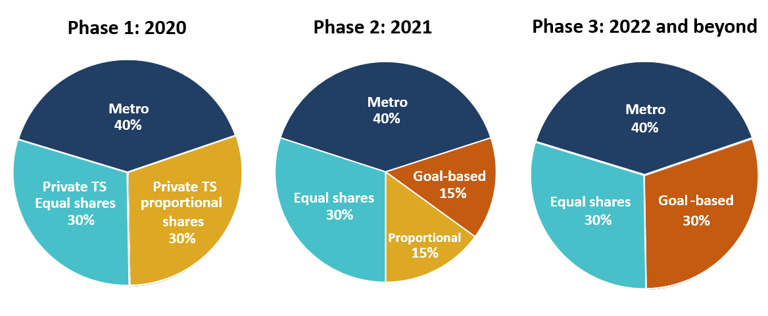
Figure 1: Phased allocation approaches; percents of adjusted regional (forecast) tonnage

Implementation Plan and Current Status
Council directed staff to finalize and implement the Phase 2 goals-based approach by mid-year 2021. Transfer stations were notified of their 2021 base tonnage allocation shares in December 2020. Criteria for 2021 goals-based allocations were finalized on March 31, 2021, and are listed in the table on the following page. Transfer stations that choose to apply must demonstrate that they meet one or more criteria by June 30, 2021, to receive additional goals-based tonnage in the current calendar year.

Metro is now developing the Phase 3 criteria and reporting requirements which will be used to determine allocations for calendar year 2022 and beyond. The standard schedule for announcing allocations is synchronized with the release of the solid waste forecast each fall. In order to return to the schedule of complete fall allocation announcements, staff must release the 2022 criteria this summer so that transfer stations that choose to apply for goals-based tonnage may have up to three months to demonstrate that they meet criteria.

Metro is committed to advancing the goals of the regional waste plan through this methodology and must also consider potential impacts on transfer stations and system stability. To achieve a balance between these two objectives, staff are designing the set of 2022 criteria to be a mix of 1) continuations of current criteria to minimize disruption and 2) revised criteria that further advance Regional Waste Plan goals.

2021 Goals-Based Allocation Criteria

Regional Waste Plan Goals | Criteria
Goal 3.0 Living Wages and Good Benefits | Ensure that all jobs in the garbage and recycling industry pay living wages and include good benefits. | - Wages for entry-level industry positions match or exceed Metro’s in-house and contracted lowest wage for entry-level industry positions, currently approximately $17.50 per hour and $15.00 per hour for staff contracted through temporary staffing agencies.
Goal 4.0 Increase Diversity in Workforce | Increase the diversity of the workforce in all occupations where people of color, women and other historically marginalized communities are underrepresented. | - Provide workforce diversity data to Metro.  This data is useful to Metro for RWP indicator reporting and monitoring and to inform a variety of RWP Goal 4 actions.
Goal 12.0 Minimize Environmental Impacts | Manage all garbage and recycling operations to reduce their nuisance, safety and environmental impacts on workers and the public. | - Use low particulate and low greenhouse gas emission fuel for rolling stock equipment at the transfer station.  OR ​  - Use R99 or qualifying renewable diesel for long-haul transport.  OR  - Use non-road equipment with Tier 4 engines or retrofitted with an Emission Control Device.
Goal 13: Invest in Communities | Invest in communities that receive garbage and recyclables from the Metro region so that those communities regard solid waste facilities as assets. | - Collect supplemental community investment fee for wet waste.  OR  - Collect community investment fee for materials other than wet waste.
Goal 14: Affordable and Consistent Rates | Adopt rates for all services that are reasonable, responsive to user economic needs, regionally consistent and well understood. | - Total charge per ton (inclusive of all fees) is no more than 5 percent over Metro’s Solid Waste fee at public stations.

Industry feedback

Comments from transfer station operators have centered on costs, timing of investments, system stability and predictability. The following themes have emerged in industry feedback, and a brief response from Metro follows each below.

- Goals-based allocations and implementation approaches
    - Transfer station investments required to meet these goals will increase costs which will be passed down and ultimately raise residential and commercial rates.
    - The goals-based approach may result in wet waste traveling to a transfer station other than the closest one. This may reduce system efficiency and increase greenhouse gas and particulate emissions relative to going to the closest facility.
    - Because each transfer station is unique, some criteria may adversely impact select transfer stations, smaller companies, etc.
    - Metro should establish longer time horizons for setting and allocating tonnage to allow for long-term facility planning and investment.

Metro perspective:
Achieving regional goals will require investment and costs. Goals are interdependent, and progress toward multiple goals may create inherent tensions but is of greater public service than maximizing progress toward any single goal.

Wet waste does not now completely flow to the nearest transfer station. In particular, companies that provide residential and/or commercial collection service and own a transfer station may bypass a Metro or competitor’s station to deliver the waste to their own facility.

Staff recognize that transfer stations differ in costs, operations, staffing, and other respects. However, custom or relative standards may possibly create legal issues by treating the stations unequally. To remove that risk, staff believe it is best practice is to design standards based a minimum or maximum standard akin to minimum wage law, clean air and drinking water standards.

Finally, no station is required to apply for any goal-based allocation. Unlike the Code's mandatory regulations, these are voluntary actions that provide bonus tons to help achieve regional goals.

Staff continue to develop allocation criteria for 2022 and beyond that will promote progress on Regional Waste Plan and regional equity goals while also providing longevity for transfer station planning and investments and overall system stability.

- Specific goals and criteria
  - Living Wages and Good Benefits
    - Total compensation represents a more complete picture of the goal of living wages and benefits.
    - If this criterion is applied to employees’ take-home pay, it would not reflect the additional costs that some private transfer stations incur when hiring staff through temporary agencies that charge a fee for their staffing services.

Metro perspective: The proposed criterion uses a minimum take-home wage for the initial round because it is measurable, meaningful and can be implemented by June 30, 2021. Staff are working to expand the criteria to advance this goal.

  - Environmental Impacts
    - Onsite equipment is a major expense that transfer station operators would not have time to act upon before 2021 allocations are decided.
    - Additional time is needed to understand costs and change long-haul contracts.

Metro perspective: Two options listed have been discussed since September 2020, and a third option (Tier 4 engines/emission control devices) has been recently added, expanding the set of actions transfer stations may take to meet this goal in a more flexible manner.

  - Investing in Communities
    - Transfer stations that implement increased or additional enhancement fees will be adversely affected relative to other facilities that do not transfer wet waste or are not applying for goals-based tonnage.
    - More information is needed about the Community Enhancement Grant Program and donations to local organizations should be considered as an alternative.

Metro perspective: Metro facilities have charged a Community Enhancement Fee on all materials since 2014 with no apparent disruption to the system. The Community Enhancement Grant Program was established in 1986 and is administered by Metro, local governments and local committee members to ensure that grant funds serve the interests of the local community.

  - Rates
    - Private transfer stations may not have flexibility to meet the rates charged by Metro’s transfer stations given private facility tonnage levels, tax burdens, and capital costs.
    - Investments made to meet other goals will increase costs and make it more difficult to match Metro’s rate.

Metro perspective: Staff propose a 5 percent buffer above Metro’s rate for the 2021 implementation to allow facilities more flexibility as they transition to goals-based allocations on the abbreviated 2021 schedule.

