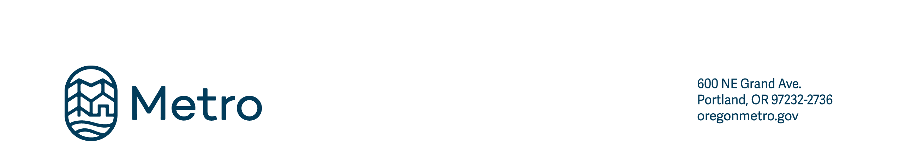
Cultural resource use permit application
Please review the Cultural Resource Use Permit Policy for guidelines associated with this permit.
CULTURAL RESOURCES AND METRO’S PARKS AND NATURAL AREAS
Metro manages public lands that are part of lands ceded from regional tribes and recognizes the unique relationship tribal people in the region have to this land. In collaboration with Portland’s Native American community, Metro has developed a culturally appropriate process for Native Americans to access land for cultural events, culturally significant plant material harvesting, or utilizing a Metro park or natural area for ceremony space. This process is different from Metro’s other special use permits in a few significant ways, but the most significant is that if a member of the Native American community is unable to fill out, scan, and email this form, they can call Metro’s Indigenous Community Liaison directly for assistance.
CULTURAL RESOURCE USE GUIDELINES (specific to the Native American community)
Cultural resource use permit
Please review the cultural resource use permit policy for guidelines and timeline associated with this permit.
- Because this type of use is educational and culturally specific, the fee is waived for a Cultural Resource Use Permit.
- Metro’s Indigenous Community Liaison will review the permit application within 10 business days of receipt of the application and coordinate the request with Metro staff. The request may be approved, approved with conditions, or denied depending on site-specific restoration priorities. See the cultural resource use policy for details.
- If you are applying to harvest culturally significant plant materials, the Indigenous Community Liaison will work with you and Metro staff to determine locations on site where the plant resource is plentiful and ready for harvest to avoid over-harvesting, as well as where it will be safe for you to harvest your cultural resources in privacy if needed. A preliminary site visit with the Indigenous Community Liaison will be necessary if you are coordinating a harvest day.
Please direct this application to Metro’s intertribal cultural resource specialist. You have the option to bypass this application and instead coordinate with the Indigenous Community Liaison directly by contacting Isabel LaCourse at indigenouscommunityliaison@oregonmetro.gov or (503) 517-6981.
APPLICANT INFORMATION
Name
Business or Organization
Address
City/State/Zip |  | Day phone
E-mail address |  | Evening phone
Contact person(s) to be present during the activity
EVENT INFORMATION
Proposed location(s) (name of park or site)
Specific area(s) requested
Description and purpose of activity (please attach an additional page if necessary)
This permit application is for a single date series of dates
Proposed date(s)
Are set-up/take-down dates different than activity date(s)? Yes No
Set-up date/time |  |  | Take-down date/time
Do you plan to harvest cultural resource plant materials on site?
Yes No If yes, what plant?
Are there any accommodations to plan for your cultural specific use? (space for fire pit, etc.)
Yes No If yes, what specifically?
Applicant |  |  | Signature

