December 2020
Transportation System Planning Guidance
for the Portland metropolitan region
A handbook for local implementation of the
Regional Transportation Functional Plan
Metro respects civil rights
Metro fully complies with Title VI of the Civil Rights Act of 1964 that requires that no person be excluded from the participation in, be denied the benefits of, or be otherwise subjected to discrimination on the basis of race, color or national origin under any program or activity for which Metro receives federal financial assistance.
Metro fully complies with Title II of the Americans with Disabilities Act and Section 504 of the Rehabilitation Act that requires that no otherwise qualified individual with a disability be excluded from the participation in, be denied the benefits of, or be subjected to discrimination solely by reason of their disability under any program or activity for which Metro receives federal financial assistance.
If any person believes they have been discriminated against regarding the receipt of benefits or services because of race, color, national origin, sex, age or disability, they have the right to file a complaint with Metro. For information on Metro’s civil rights program, or to obtain a discrimination complaint form, visit oregonmetro.gov/civilrights or call 503-797-1536.
Metro provides services or accommodations upon request to persons with disabilities and people who need an interpreter at public meetings. If you need a sign language interpreter, communication aid or language assistance, call 503-797-1700 or TDD/TTY 503-797-1804 (8 a.m. to 5 p.m. weekdays) 5 business days before the meeting. All Metro meetings are wheelchair accessible. For up-to-date public transportation information, visit TriMet’s website at trimet.org.
Metro is the federally mandated metropolitan planning organization designated by the governor to develop an overall transportation plan and to allocate federal funds for the region.
The Joint Policy Advisory Committee on Transportation (JPACT) is a 17-member committee that provides a forum for elected officials and representatives of agencies involved in transportation to evaluate transportation needs in the region and to make recommendations to the Metro Council. The established decision-making process assures a well-balanced regional transportation system and involves local elected officials directly in decisions that help the Metro Council develop regional transportation policies, including allocating transportation funds.
Regional Transportation Plan website: oregonmetro.gov/rtp
The preparation of this document was financed in part by the U.S. Department of Transportation, Federal Highway Administration and Federal Transit Administration. The opinions, findings and conclusions expressed in this document are not necessarily those of the U.S. Department of Transportation, Federal Highway Administration and Federal Transit Administration.
Table of Contents

Purpose and Background 1
Regional Transportation Functional Plan 1
Relationship to the 2040 Growth Concept and Six Desired Outcomes 1
Relationship to Regional Transportation Plan 4
Tools for Developing A Local Transportation System Plan (TSP) 4
Frequently Asked Questions 5
Checklists for Documenting Local Compliance with Regional Transportation Functional Plan 6
Table 1. Local Transportation System Plan Checklist 7
Table 2. Local Development Code Checklist 12
Table 3. Local Comprehensive Plan or Other Adopted Policy Plan Checklist 15
Appendix A A-1
Local jurisdiction public engagement and non-discrimination certification checklist A-1
This page intentionally left blank.
Purpose and Background
The purpose of this document is to help local jurisdictions, consultants and stakeholders understand and implement regional transportation policies contained in the 2040 Growth and Regional Transportation Plan.
The Regional Transportation Functional Plan (RTFP) is part of Metro Code (Chapter 3.08) and implements the policies contained in the Regional Transportation Plan. Per the Oregon Transportation Planning Rule, cities and counties local transportation system plans (TSPs) and implementing ordinances must be consistent with the RTFP to be deemed consistent with the RTP.
Typically the RTFP is reviewed and amended as part of, or following, updates to the Regional Transportation Plan. The last update to the RFTP occurred in 2012. The last update to the RTP was adopted by the Joint Policy Advisory Committee on Transportation and the Metro Council in 2018.
Technical corrections have been made to this guidance to:
- update outdated references to maps, tables and specific sections contained in the RTP;
- include additional frequently asked questions; and
- add a checklist for local jurisdictions to use to certify public involvement and non-discrimination requirements have been met for projects that will be submitted to Metro for inclusion in the RTP.
rEGIONAL tRANSPORTATION fUNCTIONAL PLAN
Relationship to the 2040 Growth Concept and Six Desired Outcomes
In 1995, the greater Portland region adopted the 2040 Growth Concept, the long-range strategy for managing growth that integrates land use and transportation system planning to preserve the region’s economic health and livability in an equitable, environmentally sound and fiscally-responsible manner.
Shown in Figure 1, the 2040 Growth Concept includes land use and transportation building blocks that express the region’s aspiration to incorporate population growth within existing urban areas as much as possible and expand the urban growth boundary only when necessary. It concentrates mixed-use and higher density development in urban centers, station communities, corridors and main streets that are well served by transit. It envisions a well-connected street network that supports biking and walking for short trips. Employment lands serve as hubs for regional commerce and include industrial land and freight facilities for truck, marine, air and rail cargo sites that enable goods to be generated and moved in and out of the greater Portland region. Freight access to industrial and employment lands is centered on rail, the freeway system and other road connections.
Figure 1 2040 Growth Concept – an integrated land use and transportation plan for the Portland region
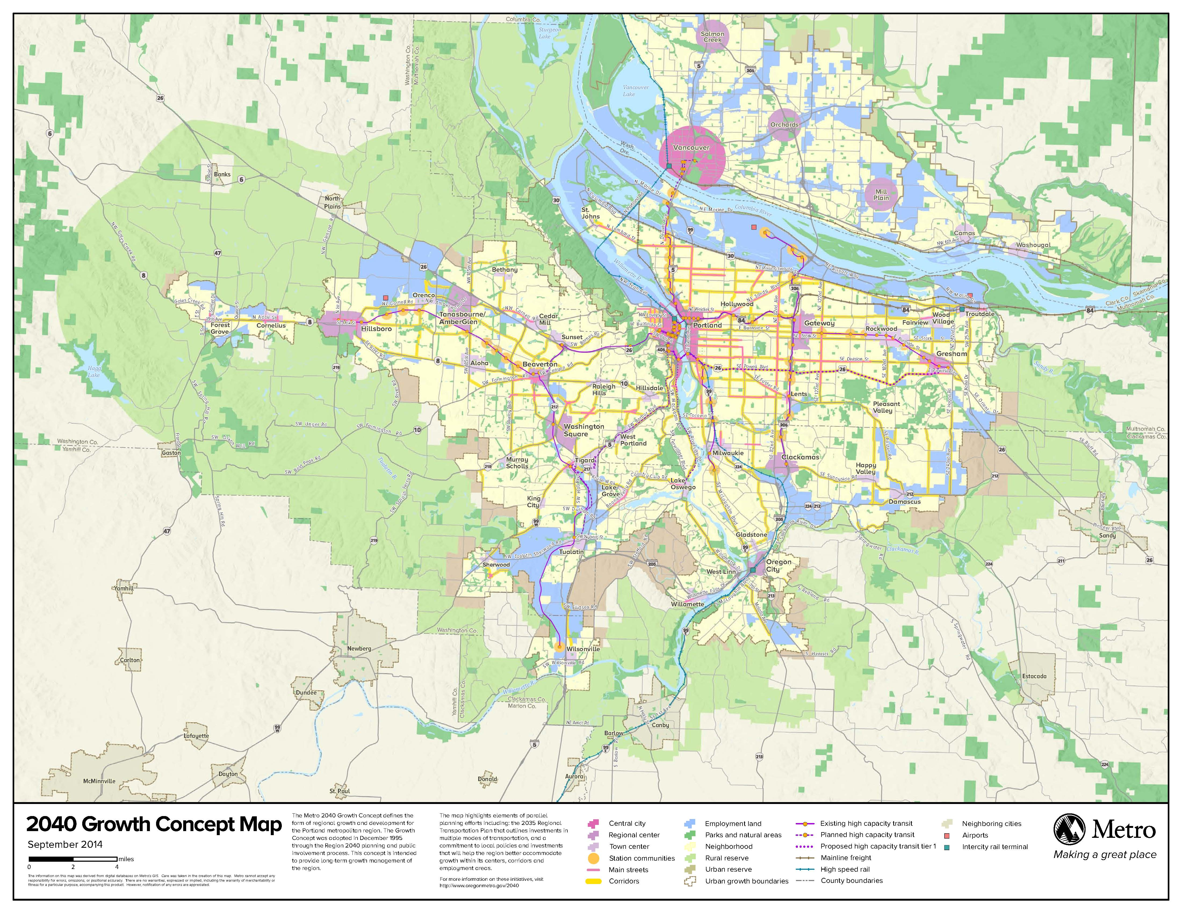
Implicit in the 2040 Growth Concept is the understanding that compact development is more affordable, sustainable, livable and fiscally responsible than urban sprawl, and will help reduce the region’s carbon footprint. Increased pedestrian and bicycle access and new transit and road capacity are needed to achieve the 2040 Growth Concept vision and support the region’s economic vitality.
In 2008, the Metro Council, with guidance from the Metro Policy Advisory Committee (MPAC), agreed that our planning efforts should support and advance achievement of the desired outcomes that the residents of this region have consistently expressed when asked. To that end, the Metro Council and MPAC adopted six desired outcomes to guide regional planning for the future.
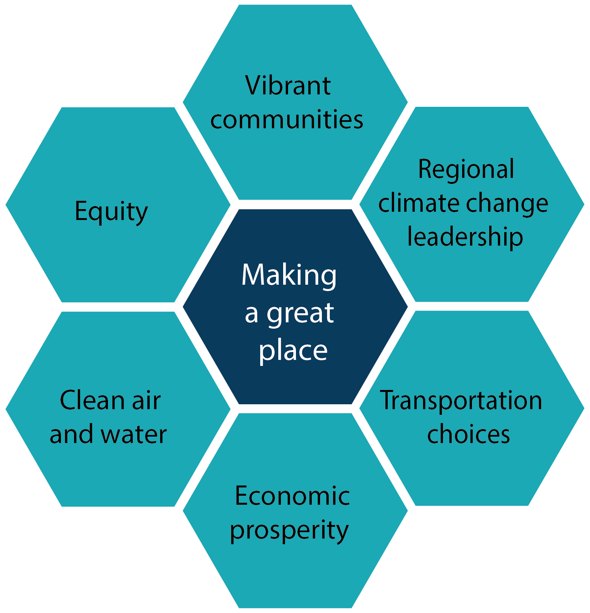
Six desired outcomes for the greater Portland region

Equity
The benefits and burdens of growth and change are distributed equitably.
Vibrant communities
People live, work and play in vibrant communities where their everyday needs are easily accessible.
Economic prosperity
Current and future residents benefit from the region’s sustained economic competitiveness and prosperity.
Safe and reliable transportation
People have safe and reliable transportation choices that enhance their quality of life.
Clean air and water
Current and future generations enjoy clean air, clean water and healthy ecosystems.
Climate leadership
The region is a leader in minimizing contributions to global warming.

– Adopted by the Metro Policy Advisory Committee and the Metro Council in 2008.
Relationship to the Regional Transportation Plan
The RTP establishes an outcomes-based planning and decision-making framework to ensure regional transportation planning and investment decisions support the six desired outcomes and implementation of the 2040 Growth Concept. The RTP is a blueprint to guide planning and investments for all forms of travel – motor vehicle, transit, bicycle and walking – and the movement of goods and freight throughout the greater Portland region. Each RTP update is shaped by looking ahead to the future to identify the region’s most urgent transportation needs and priorities for investment in all parts of the system. The plan estimates the amount of funds the region expects to have available over the planning period (typically 20 to 25 years) to build and maintain the transportation system.

The Regional Transportation Plan is supported by these strategies and modal plans:

- Regional Transit Strategy
- Regional Transportation Safety Strategy
- Regional Freight Strategy
- Emerging Technology Strategy
- Transportation System Management and Operations Plan
- Regional Active Transportation Plan
- Climate Smart Strategy

Learn more about the Regional Transportation Plan at oregonmetro.gov/rtp

The plan establishes goals, objectives, performance targets and policies to help identify regional transportation needs and guide prioritizing investments to meet those needs. Projects and programs must be in the RTP’s Financially Constrained System in order to be eligible for federal and state funding.
The Regional Transportation Functional Plan directs how city and county plans will implement the RTP through their respective comprehensive plans, local transportation system plans (TSPs) and other land use regulations. The RTFP codifies requirements that local plans must comply with to be consistent with the RTP. If a TSP is consistent with the RTFP, Metro shall deem it consistent with the RTP. The current RTP can be found at oregonmetro.gov/rtp.
Tools for Developing a Local Transportation System Plan (TSP)
This guidance and other supporting information can be found at oregonmetro.gov/tsp, including a template that has been designed to help a local jurisdiction develop its TSP. The template is organized in the order of a typical TSP statement of work (SOW) funded through the State of Oregon’s Transportation Growth Management program, though it can be used for any TSP, regardless of funding source. An on-line viewer of current RTP Network Maps and projects, RTP project lists and the RTP and appendices can be found at oregonmetro.gov/rtp.

Frequently Asked Questions
Will Metro require locals to consider widening major arterials that are not 4 lanes?
No. Metro’s arterial design concepts (RTP Table 3.3) describe a “typical” number of planned lanes for major and minor arterials, but acknowledge that either classification type can be 2 or 4 lanes (with turn planes) depending on local context.
Can a local jurisdiction use a different population and employment forecast then was used in the most recent adopted RTP?
Yes. Local plans may be based on updated, locally developed population and employment data, conditions and future year forecasts. However, population and employment data and forecasts, and the methodology for generating the data and forecast shall be coordinated at the county level, and accepted by Metro technical staff and TPAC as statistically valid. Subsequent adjustments to the population and employment allocations for traffic zones may be made in the local planning to reflect updated population and employment data and future year forecasts. Metro shall consider the updated locally developed data and forecasts in future RTP forecasts of population and employment. Subsequent differences in local TSP project recommendations that result from the differences in population and employment forecast will be resolved in the next scheduled RTP update.
How can a local jurisdiction comply with requirements to consider and document the needs of youth, seniors, people with disabilities and environmental justice populations within the city or county, including people of color, people who speak limited english and low-income families?
Metro continues to embed equity in engagement, planning and analysis to inform regional land use and transportation decision-making (and subsequent implementation), including updates to the Regional Transportation Plan.
Metro generally uses the federal Title VI framework of 'identify populations, engage historically marginalized people, analyze effects - based on what is important to those populations - of investments and plan' as a key starting point. Metro’s equity work takes the assumption that even if there is no inequitable impact finding under the Title VI framework, Metro recognizes there is a lot to do in order to correct for historical inequitable systems that have led to inequitable decisions, investments, plans and policies, so takes a more proactive engagement, planning and investment approach.
Guidance, best practices and other resources are available to support local jurisdictions in meeting these requirements, including:
- 2018 Regional Transportation Plan Transportation Equity Evaluation (Metro, 2018)
- 2018 RTP Chapter 3 Transportation Equity Policies and Implementation Actions (Metro, 2018)
- Metro Planning and Development Departmental Strategy for Achieving Racial Equity (Metro, 2018)
- Metro’s Strategic Plan to Advance Racial Equity, Diversity and Inclusion (Metro, 2016)
- Metro’s Public Engagement website, Public Engagement Guide (Metro, 2013) and resources
- U.S. Environmental Protection Agency Office of Environmental Justice website and resources
- Guidelines for Addressing Title VI and Environmental Justice in Transportation Planning (ODOT, 2015)
What public involvement requirements must be met for local TSP projects to be included in the RTP?
To be included in the RTP projects must come from adopted plans or strategies developed through a planning process that identified the project to address a transportation need on the regional transportation system. Local governments must demonstrate the planning process met the appropriate requirements for public involvement, including having provided opportunities for public comment, with specific efforts to engage communities of color, people with low-income and people who don’t speak English well. Metro prepared a public involvement and non-discrimination checklist for local jurisdictions to use to certify these requirements have been meet. The checklist is included in Appendix A.
Checklists for documenting local compliance with Regional Transportation Functional Plan
The following checklists are designed to help local jurisdictions comply with the RTFP within their TSP, development code, comprehensive plan or other adopted policy document. There is a separate checklist for each of the documents that should address RTFP requirements.
To the extent practicable, development code provisions should be adopted concurrently with adoption of the TSP and comprehensive plan amendments are adopted. When this is not possible, local jurisdictions should specify the anticipated schedule for adopting development code provisions at the time of the TSP adoption.

Table 1 Local Transportation System Plan Checklist
Regional Transportation Functional Plan Requirement | Local TSP reference?
Include, to the extent practicable, a network of major arterial streets at one-mile spacing and minor arterials or collectors at half-mile spacing, considering:
- existing topography;
- rail lines; freeways; pre-existing development, leases, easements or covenants;
- requirements of Metro’s Urban Growth Management Functional Plan Title 3 (Water Quality and Flood plains) and Title 13 (Nature in Neighborhoods), such as streams, rivers, flood plains, wetlands, riparian and upland fish and wildlife habitat areas.
- arterial design concepts in Chapter 3 of RTP (Section 3.5, Table 3.3 and Figure 3.11)
- best practices and designs as set forth in regional state or local plans and best practices for protecting natural resources and natural areas

(Title 1, Street System Design Sec 3.08.110C)
Include a conceptual map of new streets for all contiguous areas of vacant and re-developable lots and parcels of five or more acres that are zoned to allow residential or mixed-use development. The map shall identify street connections to adjacent areas and should demonstrate opportunities to extend and connect new streets to existing streets, provide direct public right-of-way routes and limit closed-end street designs consistent with Title 1, Sec 3.08.110E
(Title 1, Street System Design Sec 3.08.110D)
(Note: Applicable to both Development Code and TSP)
To the extent feasible, restrict driveway and street access in the vicinity of interchange ramp terminals, consistent with Oregon Highway Plan Access Management Standards, and accommodate local circulation on the local system. Public street connections, consistent with regional street design and spacing standards, shall be encouraged and shall supersede this access restriction. Multimodal street design features including pedestrian crossings and on-street parking shall be allowed where appropriate.
(Title 1,Street System Design Sec 3.08.110G)
Include investments, policies, standards and criteria to provide pedestrian and bicycle connections to all existing transit stops and major transit stops designated in Figure 3.16 of the RTP.
(Title 1, Transit System Design Sec 3.08.120A)
Include a transit plan consistent with transit functional classifications shown in Figure 3.16 of the RTP that shows the locations of major transit stops, transit centers, high capacity transit stations, regional bike-transit facilities, inter-city bus and rail passenger terminals designated in the RTP, transit-priority treatments such as signals, park-and-ride facilities, and bicycle and pedestrian routes, consistent with sections 3.08.130 and 3.08.140, between essential destinations and transit stops.
(Title 1, Transit System Design Sec 3.08.120B(1))
Include a pedestrian plan for an interconnected network of pedestrian routes within and through the city or county. The plan shall include:
- An inventory of existing facilities that identifies gaps and deficiencies in the pedestrian system;
- An evaluation of needs for pedestrian access to transit and essential destinations for all mobility levels, including direct, comfortable and safe pedestrian routes;
- A list of improvements to the pedestrian system that will help the city or county achieve the regional Non-SOV modal targets in Table 3.08-1 of the RTFP, and other targets established pursuant to section 3.08.230;
- Provisions for sidewalks along arterials, collectors and most local streets, except that sidewalks are not required along controlled roadways, such as freeways;
- Provision for safe crossings of streets and controlled pedestrian crossings on major arterials

(Title 1, Pedestrian System Design Sec 3.08.130A)
Include a bicycle plan for an interconnected network of bicycle routes within and through the city or county. The plan shall include:
- An inventory of existing facilities that identifies gaps and deficiencies in the bicycle system;
- An evaluation of needs for bicycle access to transit and essential destinations, including direct, comfortable and safe bicycle routes and secure bicycle parking, considering TriMet Bike Plan;
- A list of improvements to the bicycle system that will help the city or county achieve the regional Non-SOV modal targets in Table 3.08-1 of the RTFP and other targets established pursuant to section 3.08.230;
- Provision for bikeways along arterials, collectors and local streets, and bicycling parking in centers, at major transit stops shown in Figure 3.16 in the RTP, park-and-ride lots and associated with institutional uses;
- Provision for safe crossing of streets and controlled bicycle crossings on major arterials

(Title 1, Bicycle System Design Sec 3.08.140)

Include a freight plan for an interconnected system of freight networks within and through the city or county. The plan shall include:
- An inventory of existing facilities that identifies gaps and deficiencies in the freight system;
- An evaluation of freight access to freight intermodal facilities, employment and industrial areas and commercial districts;
- A list of improvements to the freight system that will help the city or county increase reliability of freight movement, reduce freight delay and achieve targets established pursuant to section 3.08.230.

(Title 1, Freight System Design Sec 3.08.150)
Include a transportation system management and operations (TSMO) plan to improve the performance of existing transportation infrastructure within or through the city or county. A TSMO plan shall include:
- An inventory and evaluation of existing local and regional TSMO infrastructure, strategies and programs that identifies gaps and opportunities to expand infrastructure, strategies and programs
- A list of projects and strategies, consistent with the Regional TSMO Plan, based upon consideration of the following functional areas:
  - Multimodal traffic management investments
  - Traveler Information investments
  - Traffic incident management investments
  - Transportation demand management investments

(Title 1, Transportation System Management and Operations Sec 3.08.160)
Incorporate regional and state transportation needs identified in the RTP as well as local transportation needs. The determination of local transportation needs based upon:
- System gaps and deficiencies identified in the inventories and analysis of transportation system pursuant to Title 1;
- Identification of facilities that exceed the Deficiency Thresholds and Operating Standards in Table 3.08-2 or the alternative thresholds and standards established pursuant to section 3.08.230;
- Consideration and documentation of the needs of youth, seniors, people with disabilities and environmental justice populations within the city of county, including minorities and low-income families.
A local determination of transportation needs must be consistent with the following elements of the RTP:
- The population and employment forecast and planning period of the RTP, except that a city or county may use an alternative forecast for the city or county, coordinated with Metro, to account for changes to comprehensive plan or land use regulations adopted after adoption of the RTP;
- System maps and functional classifications for street design, motor vehicles, transit, bicycles, pedestrians and freight in Chapter 3 of the RTP;
- Regional non-SOV modal targets in Table 3.08-1 and the Deficiency Thresholds and Operating Standards in Table 3.08-2.

When determining its transportation needs, a city or county shall consider the regional needs identified in the mobility corridor strategies in the RTP.
(Title 2, Transportation Needs Sec 3.08.210)
Evaluate the following strategies in the order listed, to meet the transportation needs determined pursuant to section 3.08.210 and performance targets and standards pursuant to section 3.08.230. The city or county shall document its choice of one or more of the strategies and why other strategies were not chosen:
- TSMO, including localized TDM, safety, operational and access management improvements;
- Transit, bicycle and pedestrian system improvements;
- Traffic-calming designs and devices;
- Land use strategies in OAR 660-012-0035(2)
- Connectivity improvements to provide parallel arterials, collectors or local streets that include pedestrian and bicycle facilities, consistent with the connectivity standards in section 3.01.110 and design classifications in Table 3.3 of the RTP,
- Motor vehicle capacity improvements, consistent with the RTP Arterial and Throughway Design and Network Concepts in Table 3.3 and Section 3.5 of the RTP, only upon a demonstration that other strategies in this subsection are not appropriate or cannot adequately address identified transportation needs.

A city or county shall coordinate its consideration of the above strategies with the owner of the transportation facility affected by the strategy. Facility design is subject to the approval of the facility owner.
If analysis under subsection 3.08.210A (Local Needs determination) indicates a new regional or state need that has not been identified in the RTP, the city or county may propose one of the following actions:
- Propose a project at the time of Metro review of the TSP to be incorporated into the RTP during the next RTP update; or
- Propose an amendment to the RTP for needs and projects if the amendment is necessary prior to the next RTP update.
(Title 2, Sec 3.08.220 Transportation Solutions)
Demonstrate that solutions adopted pursuant to section 3.08.220 (Transportation Solutions) will achieve progress toward the targets and standards in Tables 3.08-1, and 3.08-2 and measures in subsection D (local performance measures), or toward alternative targets and standards adopted by the city or county. The city or county shall include the regional targets and standards or its alternatives in its TSP.

A city or county may adopt alternative targets or standards in place of the regional targets and standards upon a demonstration that the alternative targets or standards:
- Are no lower than the modal targets in Table 3.08-1 and no lower than the ratios in Table 3.08-2;
- Will not result in a need for motor vehicle capacity improvements that go beyond the planned arterial and throughway network defined in Figure 3.13 of the RTP and that are not recommended in, or are inconsistent with, the RTP; and
- Will not increase SOV travel to a degree inconsistent with the non-SOV modal targets in Table 3.08-1.

If the city or county adopts mobility standards for state highways different from those in Table 3.08-2, it shall demonstrate that the standards have been approved by the Oregon Transportation Commission.
Each city and county shall also include performance measures for safety, vehicle miles traveled per capita, freight reliability, congestion, and walking, bicycling and transit mode shares to evaluate and monitor performance of the TSP.
To demonstrate progress toward achievement of performance targets in Tables 3.08-1 and 3.08-2 and to improve performance of state highways within its jurisdiction as much as feasible and avoid their further degradation, the city or county shall adopt the following:
- Parking minimum and maximum ratios in Centers and Station Communities consistent with subsection 3.08.410A;
- Designs for street, transit, bicycle, freight and pedestrian systems consistent with Title 1: and
- TSMO projects and strategies consistent with section 3.08.160; and
- Land use actions pursuant to OAR 660-012-0035(2).
(Title 2, Performance Targets and Standards Sec 3.08.230)
Specify the general locations and facility parameters, such as minimum and maximum ROW dimensions and the number and width of traffic lanes, of planned regional transportation facilities and improvements identified on general location depicted in the appropriate RTP map. Except as otherwise provided in the TSP, the general location is as follows:
- For new facilities, a corridor within 200 feet of the location depicted on the appropriate RTP map;
- For interchanges, the general location of the crossing roadways, without specifying the general location of connecting ramps;
- For existing facilities planned for improvements, a corridor within 50 feet of the existing right-of-way and
- For realignments of existing facilities, a corridor within 200 feet of the segment to be realigned as measured from the existing right-of-way depicted on the appropriate RTP map.

A City or county may refine or revise the general location of a planned regional facility as it prepares or revises impacts of the facility or to comply with comprehensive plan or statewide planning goals. If, in developing or amending its TSP, a city or county determines the general location of a planned regional facility or improvement is inconsistent with its comprehensive plan or a statewide goal requirement, it shall:
- Propose a revision to the general location of the planned facility or improvement to achieve consistency and, if the revised location lies outside the general location depicted in the appropriate RTP map, seek an amendment to the RTP; or
- Propose a revision to its comprehensive plan to authorize the planned facility or improvement at the revised location.
(Title 3, Defining Projects in Transportation System Plan Sec 3.08.310)
(Note: This could be adopted in TSP or other adopted policy document)
Adopt parking policies, management plans and regulations for Centers and Station Communities. Plans may be adopted in TSPs or other adopted policy documents and may focus on sub-areas of Centers. Plans shall include an inventory of parking supply and usage, an evaluation of bicycle parking needs with consideration of TriMet Bike Plan. Policies shall be adopted in the TSP. Policies, plans and regulations must consider and may include the following range of strategies:
- By-right exemptions from minimum parking requirements;
- Parking districts;
- Shared parking;
- Structured parking;
- Bicycle parking;
- Timed parking;
- Differentiation between employee parking and parking for customers, visitors and patients;
- Real-time parking information;
- Priced parking;
- Parking enforcement.
(Title 4, Parking Management Sec 3.08.410I)
If a city or county proposes a transportation project that is not included in the RTP and will result in a significant increase in SOV capacity or exceeds the planned function or capacity of a facility designated in the RTP, it shall demonstrate consistency with the following in its project analysis:
- The strategies set forth in subsection 3.08.220A(1-5) (TSMO, Transit/bike/ped system improvements, traffic calming, land use strategies, connectivity improvements)
- Complete street designs consistent with regional street design policies in Chapter 3 of the RTP (Section 3.3)
- Green street designs consistent with federal, state, regional and local regulations for stream protection.

If the city or county decides not to build a project identified in the RTP, it shall identify alternative projects or strategies to address the identified transportation need and inform Metro so that Metro can amend the RTP.
This section does not apply to city or county transportation projects that are financed locally and would be undertaken on local facilities.
(Title 5, Amendments of City and County Comprehensive and Transportation System Plans Sec 3.08.510C)

Table 2 Local Development Code Checklist
Regional Transportation Functional Plan Requirement | Local Development Code Reference?
Allow complete street designs consistent with regional street design policies in Chapter 3 of the RTP (Section 3.3)
(Title 1, Street System Design Sec 3.08.110A(1))
Allow green street designs consistent with federal, state, regional and local regulations for stream protection
(Title 1, Street System Design Sec 3.08.110A(2))
Allow transit-supportive street designs that facilitate existing and planned transit service pursuant 3.08.120B
(Title 1, Street System Design Sec 3.08.110A(3))
Allow implementation of:
- narrow streets (<28 ft curb to curb);
- wide sidewalks (at least five feet of through zone);
- landscaped pedestrian buffer strips or paved furnishing zones of at least five feet, that include street trees;
- Traffic calming to discourage traffic infiltration and excessive speeds;
- short and direct right-of-way routes and shared-use paths to connect residences with commercial services, parks, schools, hospitals, institutions, transit corridors, regional trails and other neighborhood activity centers;
- opportunities to extend streets in an incremental fashion, including posted notification on streets to be extended.
(Title 1, Street System Design Sec 3.08.110B)

Require new residential or mixed-use development (of five or more acres) that proposes or is required to construct or extend street(s) to provide a site plan (consistent with the conceptual new streets map required by Title 1, Sec 3.08.110D) that:
- provides full street connections with spacing of no more than 530 feet between connections except where prevented by barriers
- Provides a crossing every 800 to 1,200 feet if streets must cross water features protected pursuant to Title 3 and Title 13 UGMFP (unless habitat quality or the length of the crossing prevents a full street connection)
- provides bike and pedestrian accessways in lieu of streets with spacing of no more than 330 feet except where prevented by barriers
- limits use of cul-de-sacs and other closed-end street systems to situations where barriers prevent full street connections
- includes no closed-end street longer than 220 feet or having no more than 25 dwelling units

(Title 1, Street System Design Sec 3.08.110E)

Establish city/county standards for local street connectivity, consistent with Title 1, Sec 3.08.110E, that applies to new residential or mixed-use development (of less than five acres) that proposes or is required to construct or extend street(s).

(Title 1, Street System Design Sec 3.08.110F)
(Note: Applicable to both Development Code and TSP)
To the extent feasible, restrict driveway and street access in the vicinity of interchange ramp terminals, consistent with Oregon Highway Plan Access Management Standards, and accommodate local circulation on the local system. Public street connections, consistent with regional street design and spacing standards, shall be encouraged and shall supersede this access restriction. Multimodal street design features including pedestrian crossings and on-street parking shall be allowed where appropriate.
(Title 1,Street System Design Sec 3.08.110G)
Include Site design standards for new retail, office, multi-family and institutional buildings located near or at major transit stops shown in Figure 3.16in the RTP:
- Provide reasonably direct pedestrian connections between transit stops and building entrances and between building entrances and streets adjoining transit stops;
- Provide safe, direct and logical pedestrian crossings at all transit stops where practicable

At major transit stops, require the following:
- Locate buildings within 20 feet of the transit stop, a transit street or an intersection street, or a pedestrian plaza at the stop or a street intersections;
- Transit passenger landing pads accessible to disabled persons to transit agency standards;
- An easement or dedication for a passenger shelter and an underground utility connection to a major transit stop if requested by the public transit provider;
- Lighting to transit agency standards at the major transit stop;
- Intersection and mid-block traffic management improvements as needed and practicable to enable marked crossings at major transit stops.
(Title 1, Transit System Design Sec 3.08.120B(2))
(Note: This could be adopted in the Comprehensive plan or the TSP)
As an alternative to implementing site design standards at major transit stops (section 3.08.120B(2), a city or county may establish pedestrian districts with the following elements:
- A connected street and pedestrian network for the district;
- An inventory of existing facilities, gaps and deficiencies in the network of pedestrian routes;
- Interconnection of pedestrian, transit and bicycle systems;
- Parking management strategies;
- Access management strategies;
- Sidewalk and accessway location and width;
- Landscaped or paved pedestrian buffer strip location and width;
- Street tree location and spacing;
- Pedestrian street crossing and intersection design;
- Street lighting and furniture for pedestrians;
- A mix of types and densities of land uses that will support a high level of pedestrian activity.
(Title 1, Pedestrian System Design Sec 3.08.130B)
Require new development to provide on-site streets and accessways that offer reasonably direct routes for pedestrian travel.
(Title 1, Pedestrian System Design Sec 3.08.130C)
Establish parking ratios, consistent with the following:
- No minimum ratios higher than those shown on Table 3.08-3.
- Mo maximum ratios higher than those shown on Table 3.08-3 and illustrated in the Parking Maximum Map. If 20-minute peak hour transit service has become available to an area within a one-quarter mile walking distance from bus transit one-half mile walking distance from a high capacity transit station, that area shall be removed from Zone A. Cities and counties should designate Zone A parking ratios in areas with good pedestrian access to commercial or employment areas (within one-third mile walk) from adjacent residential areas.

Establish a process for variances from minimum and maximum parking ratios that include criteria for a variance.
Require that free surface parking be consistent with the regional parking maximums for Zones A and B in Table 3.08-3. Following an adopted exemption process and criteria, cities and counties may exempt parking structures; fleet parking; vehicle parking for sale, lease, or rent; employee car pool parking; dedicated valet parking; user-paid parking; market rate parking; and other high-efficiency parking management alternatives from maximum parking standards. Reductions associated with redevelopment may be done in phases. Where mixed-use development is proposed, cities and counties shall provide for blended parking rates. Cities and counties may count adjacent on-street parking spaces, nearby public parking and shared parking toward required parking minimum standards.
Use categories or standards other than those in Table 3.08-3 upon demonstration that the effect will be substantially the same as the application of the ratios in the table.
Provide for the designation of residential parking districts in local comprehensive plans or implementing ordinances.
Require that parking lots more than three acres in size provide street-like features along major driveways, including curbs, sidewalks and street trees or planting strips. Major driveways in new residential and mixed-use areas shall meet the connectivity standards for full street connections in section 3.08.110, and should line up with surrounding streets except where prevented by topography, rail lines, freeways, pre-existing development or leases, easements or covenants that existed prior to May 1, 1995, or the requirements of Titles 3 and 13 of the UGMFP.
Require on-street freight loading and unloading areas at appropriate locations in centers.
Establish short-term and long-term bicycle parking minimums for:
- New multi-family residential developments of four units or more;
- New retail, office and institutional developments;
- Transit centers, high capacity transit stations, inter-city bus and rail passenger terminals; and
- Bicycle facilities at transit stops and park-and-ride lots.
(Title 4, Parking Management Sec 3.08.410)
Table 3 Local Comprehensive Plan or Other Adopted Policy Plan Checklist
Regional Transportation Functional Plan Requirement | Local Comprehensive Plan/other Adopted Plan Reference?
(Note: This could be located in Development code or Comprehensive Plan)
As an alternative to implementing site design standards at major transit stops (section 3.08.120B(2), a city or county may establish pedestrian districts with the following elements:
- A connected street and pedestrian network for the district;
- An inventory of existing facilities, gaps and deficiencies in the network of pedestrian routes;
- Interconnection of pedestrian, transit and bicycle systems;
- Parking management strategies;
- Access management strategies;
- Sidewalk and accessway location and width;
- Landscaped or paved pedestrian buffer strip location and width;
- Street tree location and spacing;
- Pedestrian street crossing and intersection design;
- Street lighting and furniture for pedestrians;
- A mix of types and densities of land uses that will support a high level of pedestrian activity.
(Title 1, Pedestrian System Design Sec 3.08.130B)
When proposing an amendment to the comprehensive plan or to a zoning designation, consider the strategies in subsection 3.08.220A as part of the analysis required by OAR 660-012-0060. If a city or county adopts the actions set forth in 3.08.230E (parking ratios, designs for street, transit, bicycle, pedestrian, freight systems, TSMO projects and strategies, and land use actions) and section 3.07.630.B of Title 6 of the UGMFP, it shall be eligible for an automatic reduction of 30 percent below the vehicular trip generation rates recommended by the Institute of Transportation Engineers when analyzing the traffic impacts, pursuant to OAR 660-012-0060, of a plan amendment in a Center, Main Street, Corridor or Station Community.
(Title 5, Amendments of City and County Comprehensive and Transportation System Plans Sec 3.08.510A,B)
(Note: This could be located in Development Code, TSP or other adopted policy document)
Adopt parking policies, management plans and regulations for Centers and Station Communities. Plans may be adopted in TSPs or other adopted policy documents and may focus on sub-areas of Centers. Plans shall include an inventory of parking supply and usage, an evaluation of bicycle parking needs with consideration of TriMet Bike Plan. Policies shall be adopted in the TSP. Policies, plans and regulations must consider and may include the following range of strategies:
- By-right exemptions from minimum parking requirements;
- Parking districts;
- Shared parking;
- Structured parking;
- Bicycle parking;
- Timed parking;
- Differentiation between employee parking and parking for customers, visitors and patients;
- Real-time parking information;
- Priced parking;
- Parking enforcement.
(Title 4, Parking Management Sec 3.08.410I)



Appendix A. Local jurisdiction public engagement and non-discrimination certification checklist

Background and purpose
Use of this checklist is intended to ensure local jurisdictions have offered an adequate opportunity for public engagement, including identifying and engaging historically marginalized communities, during development of local transportation system plans, subarea plans or strategies, topical plans or strategies (e.g., safety), modal plans or strategies (e.g., freight) and transit service plans that will identify projects for inclusion in the Regional Transportation Plan.
Metro is required to comply with federal (U.S. Department of Transportation, Federal Highway Administration and Federal Transit Administration) and state (ODOT) guidance on public engagement and on Title VI of the Civil Rights Act and other civil rights requirements. Documentation of the local actions described below may be requested by regulators; if such a request is unable to be met, the Regional Transportation Plan itself may be found to be out of compliance, requiring regional corrective action.
Instructions
Applicants must complete this certification, comprising the plan development checklist (section A), summary of non-discriminatory engagement (section B) and certification statement (section C), for plans that include projects that will be submitted to Metro for inclusion in the Regional Transportation Plan.
One completed certification form is required for the list of projects submitted by the jurisdiction, agency or special district for the Regional Transportation Plan.
Jurisdictions should keep referenced records on file in case of a request for information. Records should be retained until the related local transportation system plan, subarea plan or strategy, modal plan or strategy or transit service plan is superseded – or the submitted projects have been completed – plus six years. Retained records do not have to be submitted unless requested by Metro, state regulators or federal regulators.
Forward questions regarding this appendix to the Civil Rights program manager, Clifford Higgins at clifford.higgins@oregonmetro.gov or 503-797-1932.

A. Public involvement checklist
- At the beginning of the agency’s transportation system, topical modal, subarea or transit service plan, a public engagement plan was developed to encourage broad-based, early and continuing opportunity for public involvement.
Retained records: public engagement plan and/or procedures
- During the development of the agency’s transportation system, topical, modal, subarea or transit service plan, a jurisdiction-wide demographic analysis was completed to understand the locations of communities of color, people with limited English proficiency, people with low income and, to the extent reasonably practicable, people with disabilities, older adults and youth in order to include them in engagement opportunities.
Retained records: summary of or maps illustrating jurisdiction-wide demographic analysis
- Throughout process, public notices were published and requests for input were sent in advance of the project start, engagement activity or input opportunity.
Retained records: dated copies of notices (may be included in retained public engagement reports)
- Throughout the process, public documents included a statement of non-discrimination (Metro can provide a sample).
Retained records: public documents, including meeting agendas and reports
- Throughout the process, timely and accessible forums for public input were provided.
Retained records: descriptions of opportunities for ongoing engagement, descriptions of opportunities for input at key milestones, public meeting records, online and community survey results (may be included in retained public engagement reports)
- Throughout the process, appropriate interested and affected groups were identified, and contact information was maintained, in order to share plan information; updates were provided for key decision points; and opportunities to engage and comment were provided.
Retained records: list of interested and affected parties, dated copies of communications and notices sent, descriptions of efforts to engage the public, including strategies used to attract interest and obtain initial input, summary of key findings; for announcements sent by mail or email, documented number of persons/groups on mailing list (may be included in retained public engagement reports)
- Throughout the process, focused efforts were made to engage historically marginalized populations, including people of color, people with limited English proficiency and people with low income, as well as people with disabilities, older adults and youth. Meetings or events were held in accessible locations with access to transit. Language assistance was provided, as needed, such as translation of key materials, use of a telephone language line service to respond to questions or take input in different languages, and interpretation at meetings or events.
Retained records: description of focused engagement efforts, list of community organizations and/or community members representing diverse populations with whom coordination or consultation occurred, description of language assistance resources and how they were used, dated copies of communications and notices, copies of translated materials, summaries of key findings (may be included in retained public engagement reports)
- Public comments were considered throughout the process, and comments received on the staff recommendation were compiled, summarized and responded to, as appropriate.
Retained records: summary of comments, key findings and changes made to final staff recommendation or adopted plan to reflect public comments (may be included in retained public engagement reports or legislative staff reports)
- Adequate notification was provided regarding final adoption of the plan, including how to obtain more detailed information, at least 15 days in advance of adoption. Notice included information on providing public testimony.
Retained records: dated copies of the notices; for announcements sent by mail or email, documentation of number of persons/groups on mailing list (may be included in retained public engagement reports or legislative staff reports)
B. Summary of non-discriminatory engagement
Attach a summary (1-2 pages) of the key elements of the public engagement process for development of local transportation system plans, subarea plans or strategies, modal plans or strategies or transit service plans, including outreach to people of color, people with limited English proficiency and people with low income.
C. Certification statement
certifies the information provided on this checklist is accurate.
(agency).
As attested by:
(agency manager signature) | (name and title)

(date)

About Metro
If you picnic at Blue Lake or take your kids to the Oregon Zoo, enjoy symphonies at the Schnitz or auto shows at the convention center, put out your trash or drive your car – we’ve already crossed paths.
So, hello. We’re Metro – nice to meet you.
In a metropolitan area as big as Portland, we can do a lot of things better together. Join us to help the region prepare for a happy, healthy future.
Stay in touch with news, stories and things to do.
oregonmetro.gov/news
Follow oregonmetro


Metro Council President
Lynn Peterson
Metro Councilors
Shirley Craddick, District 1
Christine Lewis, District 2
Craig Dirksen, District 3
Juan Carlos Gonzalez, District 4
Sam Chase, District 5
Bob Stacey, District 6
Auditor
Brian Evans

600 NE Grand Ave.
Portland, OR 97232-2736
503-797-170

December 11, 2020

