2022-2024 Regional Flexible Funds Project Application

introduction
This application is organized to consider, assess, screen, and select Regional Flexible Fund Allocation (RFFA) projects. The assessment is focused on first determining a candidate project’s applicability to the RFFA program and their technical feasibility. Upon that assessment, promising projects will be assessed on the merits of their intended project outcomes that will be used for project scoring.

To be applicable to the RFFA program, a project must be at least one of the following project types:
- Active Transportation and Complete Streets, or
- Freight and Economic Development Initiatives

Each project should demonstrably support the four 2018 Regional Transportation Plan (RTP) investment priorities:
- Advancing Equity
- Improving Safety
- Implementing the region’s Climate Smart Strategy
- Managing Congestion

Although information from the entire application may be used to inform project scoring, the questions presented in the section, “Project Outcomes” are directly related to scoring and evaluation criteria and the answers to these questions will directly inform the project scoring.

After all relevant questions are completed, please secure the required signatures as indicated at the end of this application form, and email it, along with other required information and supporting documentation to rffa@oregonmetro.gov. Applications MUST be received by 4:00 p.m. on Friday, June 21, 2019 in order to be considered.

applicant information
- Jurisdiction name Click here to enter text.
- Contact info: Name, phone #, email Click here to enter text.
- Funding category (check one): ☐ Active Transportation ☐ Freight ☐ Both
- Project name. Click here to enter text.
- Describe the project purpose. What problems or issues is the project intended to address? Click here to enter text.

project readiness
The following questions intend to gather information about how developed the project is and the steps that will still be required to complete the project. This section will be used for screening project feasibility.

Project Detail
- Is this project on the 2018 RTP Constrained list? ☐ Yes ☐ No
- What is the RTP Project ID #? Click here to enter text.
- In which RTP network and policy map(s) is the project included? Check all that apply, indicate specific functional classification.
☐ High Injury Corridor (or ODOT ARTS Hotspot map) Click here to enter text.
☐ Bicycle Click here to enter text.
☐ Pedestrian Click here to enter text.
☐ Freight Click here to enter text.
☐ Transit Click here to enter text.
- List the project beginning and ending points. What specific streets/intersections are included in the project area? Click here to enter text.
- Is the project included in an adopted local transportation safety plan or audit? ☐ Yes ☐ No Please describe. Click here to enter text.
- Describe the non-RFFA funding sources available and amounts necessary for the project to be completed. How secured is the funding for each funding source (Certain, Probable, or Competitive?) Click here to enter text.
- Which Project Development Stages are to be considered for RFFA funding? Click here to enter text.
- If your project is found to not be as far along as indicated or has specific challenges that need to be (re)addressed to improved technical feasibility, are you interested in RFFA funding for project development activities? ☐ Yes ☐ No
- Attach or describe the project schedule and include information about important schedule considerations or drivers. Click here to enter text.

Project Completeness
- At what stage of the project development process is the project, and what is the status of each project stage (refer to Defining Project Development Stages above)? Click here to enter text.
- Is right of way (ROW) acquisition likely? Will the project need any unique ROW requirements such as temporary easements, special coordination with other agencies? What is the status of the ROW acquisition task of the project? Click here to enter text.
- What project development (project study reports, transportation safety plan, safety audit, feasibility studies) has been completed? How recent are these reports or this project development, and are they still relevant? Are they in digital format for possible transfer? Click here to enter text.
- Does the project area intersect with Title 13 resource areas, wetlands, cemeteries, railroad tracks, Native American burial grounds, protected species habitat, or any other qualifiers that would require permitting? Click here to enter text.
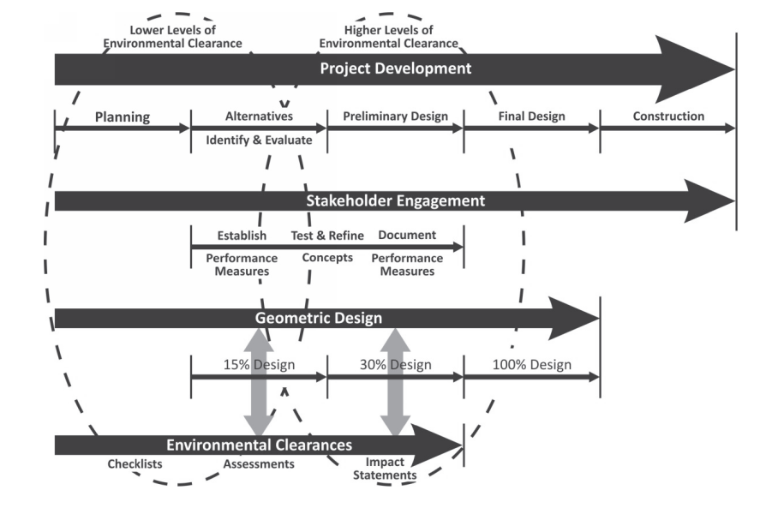
- To what extent has environmental permitting been scoped or completed? Click here to enter text.
Community Support
- What needs expressed by community members (e.g., unsafe crossing; egregiously long red lights) does the project address? Click here to enter text.
- Which community partners are involved? Click here to enter text.
- Describe the agency and community support (and any opposition) for the project. Discuss the focus on equity and stakeholder engagement process. Click here to enter text.

Interagency Connections
- Are TriMet, SMART, or adjacent or overlapping jurisdictions (counties, cities) involved in and supportive of the project? Click here to enter text.
- Is the project on or does it connect with a separate agency facility? Indicate all potentially involved agencies’ awareness of and cooperation with the project. Potential agencies include Oregon Department of Transportation (ODOT) (Highway, Rail divisions and others as required), railroads, utilities, Bonneville Power Administration, or Port of Portland. Click here to enter text.
- Will utilities need to be relocated? Who owns the utilities and what is their level of awareness and support for the utility relocation? Click here to enter text.
- Do you have design control consistently across the project area? If other agencies are affected by this project, do you have the necessary documentation of agreement regarding design elements reflected within this project? (Please obtain signatures as indicated on the Signature Page of this application.) Click here to enter text.

project risks
The following questions intend to identify potential risks to project completion.

- Has a person(s) with the proper authority reviewed and agreed to the project design, and signed off on this application? ☐ Yes ☐ No
- Are there any anticipated risks for the following:
  - Right of way (ROW)
    - Are ROW acquisition costs included in the cost estimate? Click here to enter text.
    - Were the federal Right of Way Uniform Act’s acquisition and negotiation processes performed during the ROW acquisition stage or considered in the schedule and budget, for those projects which have not yet performed ROW acquisition? Click here to enter text.
  - Utility Relocation
    - Are utility relocation costs included in the cost estimate? Click here to enter text.
  - Stormwater considerations
    - Water quantity Click here to enter text.
    - Water quality Click here to enter text.
  - Environmental and Permitting
    - Have potential State environmental (SEPA)/ National Environmental Policy Act (NEPA) impacts been identified? Click here to enter text.
  - Schedule Click here to enter text.
  - Budget Click here to enter text.
  - Staff availability
    - Does the agency have sufficient and qualified staffing resources to lead, manage, and deliver the project? Please describe. Click here to enter text.
project design
Project designs will be scored on the level of safety and environmental improvements they can provide. A project that includes as many safety and environmental mitigation elements as feasible will more completely meet the criteria.

- Describe the project elements and countermeasures that address safety. Click here to enter text.
- What countermeasures are included that reduce conflicts between modes (vehicles, pedestrians, bicycles, railroad crossings) and improve safety? (Use Appendix C design checklist, check all that apply) Click here to enter text.
- What specific project design elements are aimed at reducing environmental impacts (street trees, bioswales, etc.)? Click here to enter text.
- Are there additional design elements or countermeasures not on the checklist that are included in the project design that will improve safety and environmental outcomes? Click here to enter text.

project outcomes
Projects will be scored in terms of their ability to create positive outcomes that align with RFFA priorities and regional goals. The following questions aim to gather details directly related to those potential outcomes. Please provide all relevant data to support your response, using Metro-provided data or additional sources. Metro staff will provide data to the scoring committee to confirm

Affordability/Equity
- Is the project in an Equity Focus Area? ☐ Yes ☐ No Please indicate which Focus Area. Click here to enter text.
- List the community places, affordable housing, and Title 1 schools within ¼ mile of project. Click here to enter text.
- What are the estimated totals of low-income, low-English proficiency, non-white, seniors and youth, and persons with disabilities who will benefit from this project? Click here to enter text.
- What are the barriers faced by these communities that the project addresses or overcomes, and how will these populations benefit from this project? Click here to enter text.
- What contracting opportunities are available to Office for Business Inclusion and Diversity (COBID) firms through this project? What is your agency’s policy, history, or removing of barriers to hire and advance COBID firms in infrastructure projects? Click here to enter text.

Safety
- How many fatal or serious injury crashes have occurred in the project area in the last 5 years (or most recent 5 years of available crash data)? Click here to enter text.
- How does the project aim to reduce the number of fatal or serious injury crashes? Click here to enter text.
- How does the project remove or mitigate conflicts, with (including) active transportation, railroad crossings, turning movements, and others? (Use Appendix C design checklist, indicate all that apply) Click here to enter text.

System Completion
- What network gap(s) will be completed by this project? How will system connectivity or network deficiencies be improved? Click here to enter text.
- How will access to active transportation be improved? What specific barriers in addition to the network gaps identified above will the project eliminate? Click here to enter text.

Multimodal Travel, Mode Share, and Congestion
- How will the project reduce transit delay and improve transit reliability? Click here to enter text.
- How does the project improve connections to transit and employment or residential sites/areas? Click here to enter text.
- How will the project reduce vehicle trips or VMT (other than freight-related trips)? Click here to enter text.
- How does the project reduce the need for throughway expansion? Click here to enter text.

Climate Change and Environmental Impact
- Describe the measures included to specifically mitigate the project’s greenhouse gas emissions and environmental impact. Click here to enter text.
- What specific project design elements are aimed at reducing environmental impacts (street trees, bioswales, etc.)? Click here to enter text.

Freight Related Impact
- How does the project address freight travel time reliability and reoccurring or nonrecurring congestion affecting freight goods movement? Click here to enter text.
- Is this project on a “Reduction Review Route” (defined and stipulated by statute; OAR 731-012 and ORS 366.215) and to what extent has coordination occurred with the freight industry? Click here to enter text.
- If there is freight delay along the corridor, when does this delay occur, to what extent is there delay, and how does this project address that delay? Click here to enter text.

Employment/Economic Development
- Describe the employment area(s) served by this project. What is the number of current and projected jobs in traded sectors? Click here to enter text.
- Describe how the project supports and catalyzes low-carbon and resource efficient economic sectors. Click here to enter text.

Project Leverage
- How does this project leverage other funding sources? Click here to enter text.
- Will the receipt of RFFA funding position the region to take advantage of federal and state funding opportunities as they arise? If so, explain. Click here to enter text.
- Will this help advance any Transportation Systems Management and Operations (TSMO) goals and strategies? Click here to enter text.
- Is this project on the Regional Emergency Transportation Network? Will this project help improve resiliency of the transportation network? If so, describe how. Click here to enter text.
project cost estimate
- What is the source of the project cost estimate?
☐ Conceptual: These cost estimates are used where a significant need has been identified but a detailed project scope has not been developed. These cost estimates have the potential to change significantly as the project scope becomes more defined.
☐ Planning level: These cost estimates are based on a generally defined scope. Cost estimates are usually based on limited field-work and general cost assumptions. No actual design work has been done prior to the development of these cost estimates. The cost estimate could still change significantly as design work begins, but the estimate is more reliable than the conceptual estimates. (e.g., comprehensive plan, TSP, Metro cost estimate worksheet, corridor plan).
☐ Engineering level: These cost estimates are based on actual preliminary design work. If done for all facets of the project and there are no further additions to the project scope, these estimates should represent a fairly accurate cost for the project. (e.g. detailed planning report, preliminary engineering, final design, NEPA documentation, etc.)
- During what project development stage (refer to page 9 of the RFFA application guidebook) was the cost estimate created?
☐ Planning
☐ Alternatives Identification and Evaluation
☐ Preliminary Design
☐ Final Design
- What year was the cost estimate created? Does it include any escalation factors and to what year? Click here to enter text.
- To what extent were the following considered during cost estimating? Click here to enter text.
  - Right of way (ROW)
  - Utility relocation or underground
  - Stormwater considerations
  - Environmental mitigation strategies
  - Bridge, railroad, or major facility impacts
  - Retaining walls
  - Clearing and grading
  - Removal of current pavement or facilities
  - Signing and pavement markings
  - Sidewalk and street furniture
  - Street trees, landscaping, irrigation
  - Mobilization, staging, and traffic control
  - Staff availability or need for outside services
- Please attach your cost estimate. Verify that it includes the following items:
- Unit cost assumptions
- Contingency assumptions

signature page
All relevant applicant agency and other agency staff with authority must attest to the design and cost estimates of the project, and that proper coordination and cooperation exists between all parties. Please attach additional signature pages as warranted.

Applicant agency staff signatures:

Project manager __________________________________________________________

Engineering __________________________________________________________

Right of Way __________________________________________________________

Environmental __________________________________________________________

Other agency signatures (as required):

ODOT Highway __________________________________________________________

ODOT Rail __________________________________________________________

TriMet __________________________________________________________

SMART __________________________________________________________

Utilities __________________________________________________________

__________________________________________________________

__________________________________________________________

Railroads __________________________________________________________

Other (please indicate) __________________________________________________________

Project must be on the 2018 RTP Constrained list, available for download at: oregonmetro.gov/RTP or oregonmetro.gov/sites/default/files/2019/04/02/2018-RTP-Master-Project-List-All-Projects-20190315.xls
Please refer to guidance found in the RFFA nomination process handbook.
Available for download at: oregonmetro.gov/urban-growth-management-functional-plan
As indicated on final page of application.
2018 RTP Environmental Assessment and Potential Mitigation Strategies (Table 4 summarizes potential strategies by resource areas and pages 34 to 59 identify all RTP Projects that intersect with one or more environmental resource area) oregonmetro.gov/sites/default/files/2019/03/01/RTP-Appendix_F_EnvironmentalAnalysisMitigationStrategies190301.pdf
Community places are defined as key local destinations such as schools, libraries, grocery stores, pharmacies, hospitals and other medical facilities, general stores, parks, greenspaces, and other places that provide key services and/or daily needs.
Traded sector industries as indicated in the Economic Value Atlas, available at: oregonmetro.gov/tools-partners/guides-and-tools/economic-value-atlas
Clean Technology industry sectors as defined in the Oregon Business Plan, https://oregonbusinessplan.org/about-the-plan/industry-clusters/
oregonmetro.gov/sites/default/files/2019/04/05/Regional_Emergency_Transportation_Routes_2006.pdf

